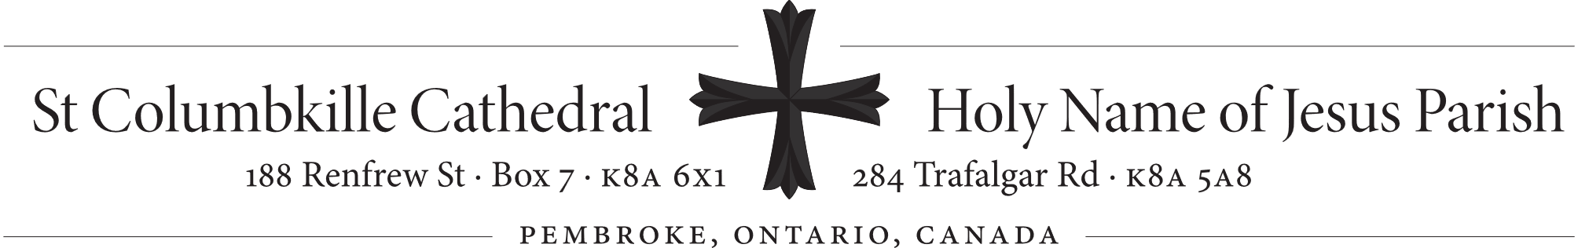
4th Sunday of Easter May 11, 2025
Most Reverend Michael Brehl, C.Ss.R., Bishop of Pembroke
Rector/Pastor: Rev. Mitchell Beachey, P.P., V. F. Parochial Vicar: Rev. Peter Do Deacon: Deacon. Adrien Chaput. In residence: Rev. Mervin Coulas, retired
St Columbkille Cathedral Office | Holy Name Parish Office
Office hours: Mon.–Fri.: 9am–noon; 1pm–4pm.  Secretaries: Mrs. Lydia Demeter-Lewis, Mrs. Christine Patriquin  Phone: 613-732-8513  Email: stcolumbkille@nrtco.net | Office hours: Mon., Tue., Fri.: 9am–3pm (Located at 188 Renfrew St)  Secretary: Mrs. Mary Van Gool  Phone: 613-732-3355  Email: holynamepembroke@outlook.com
This Bulletin is posted weekly to www.holynamecolumbkille.com

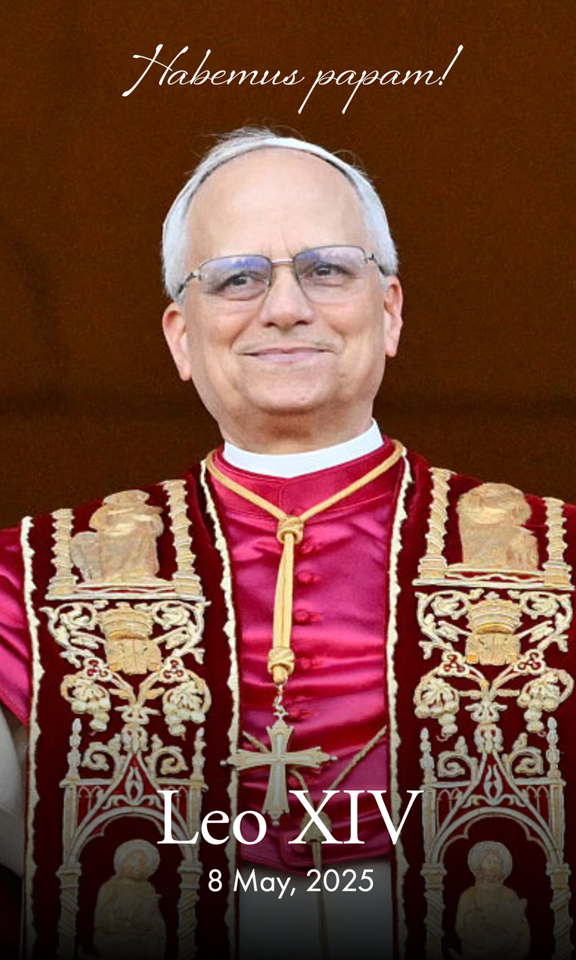
Prayer for the Pope
O God, shepherd and ruler of all the faithful,
look favourably on your servant Leo XVI,
whom you have set at the head of your
Church as her shepherd;
grant, we pray, that by word and example
he may be of service to those
over whom he presides so that,
together with the flock entrusted to his care,
he may come to everlasting life.
Through our Lord Jesus Christ, your Son,
who lives and reigns with you in the unity
of the Holy Spirit, God, for ever and ever.

Pope Leo XIV was born in Chicago, Illinois, on 14 September 1955. As a member of the Order of Saint Augustine (O.S.A.), in which he held various leadership positions, he dedicated many years of service to the Augustinian missions in Peru as a priest and seminary professor. He was eventually appointed Bishop of Chiclayo, Peru, by Pope Francis. As a Bishop of the Church in Peru, he served as Vice President and member of the Permanent Council of the Peruvian Bishops’ Conference. In 2023, Pope Francis appointed him as Prefect of the Dicastery of Bishops and elevated him to the College of Cardinals. Pope Leo XIV holds a doctorate in canon law from the Pontifical College of St. Thomas Aquinas in Rome.
Entrance Antiphon: The merciful love of the Lord fills the earth; by the word of the Lord the heavens were made, alleluia.
Communion Antiphon: The Good Shepherd has risen, who laid down his life for his sheep and willingly died for his flock, alleluia

COMMON ANNOUNCEMENTS

Pastoral Appointments – May 2025: The Most Reverend Michael Brehl, C.Ss.R. announces the following pastoral appointments:
Reverend Kerry Brennan is appointed administrator of St. Michael Parish, Douglas, St. Pius V Parish, Osceola and Sacred Heart Mission, Cobden, while remaining pastor of St. Francis Xavier Parish, Renfrew and Most Precious Blood Parish, Calabogie. At the same time Father Brennan is appointed for one year in view of his 75th birthday in 2026 in accordance with Canon 517 as moderator of these parishes entrusted ‘in solidum’, together with Father Michael Coyne. This appointment is effective July 2, 2025.
Reverend Lukas Časta is appointed parochial vicar of Our Lady of Lourdes Parish, Pembroke, Our Lady of Mount Carmel Parish, LaPasse and Our Lady of Grace Mission, Westmeath. This appointment is effective July 2, 2025.
Reverend Michael Coyne is appointed in accordance with Canon 517 ‘in solidum’ with Father Kerry Brennan to provide pastoral care to St. Francis Xavier Parish, Renfrew, Most Precious Blood Parish, Calabogie, St. Michael Parish, Douglas, St. Pius V Parish, Osceola and Sacred Heart Mission, Cobden. This appointment is effective July 2, 2025.
Reverend Dan Kelly concludes his service to the Diocese of Pembroke, effective May 28, 2025. Bishop Brehl thanks Father Kelly for his ministry as administrator of St. John Chrysostom, Arnprior and Our Lady of Perpetual Help Parish, Braeside.
Reverend William Kenney concludes his appointment as administrator of St. Michael Parish, Douglas, St. Pius V Parish, Osceola and Sacred Heart Mission, Cobden. Father Kenney will continue to be in residence at St. Francis Xavier Parish in Renfrew and assist Father Brennan and Father Coyne, as well as continue as priest chaplain to Marianhill in Pembroke.
Reverend Robert Ryan is appointed for a temporary period of time as administrator of St. John Chrysostom Parish, Arnprior and Our Lady of Perpetual Help Parish, Braeside. This appointment is effective May 28, 2025.
Reverend Christopher Shalla is appointed to carry out ministry to health care centres in Pembroke with residency at Cathedral House. This appointment is effective immediately.
Bishop Brehl confers the office of pastor, effective May 8, 2025 on the following priests assigned as parish administrators in June 2024 during the vacancy of the diocese:
Reverend James Beanish: St Andrew Parish, Killaloe and Our Lady of the Angels, Brudenell.
Reverend Michael Lund: St. James Parish, Eganville, Our Lady of the Nativity Mission,
Pikwakanagan and St. Ann Parish, Cormac.
Reverend Réal Ouellette: Paroisse St-Jean-Baptiste, Pembroke, Ontario.
Reverend Cyril Okebanama: St. Anne Parish, Mattawa, St-Thomas-d’Aquin Parish, Astorville,
Sacred Heart Parish, Corbeil, St. Bernadette Parish, Bonfield.

Prayers: For the repose of the soul of Sister Loretta Rice, (Sister Columba) CSJ, who passed away at Mount St. Joseph, Peterborough, on May 3. Sister Loretta faithfully served the Congregation of the Sisters of St. Joseph for over 66 years.

Parish Supper: At Our Lady of Perpetual Help Parish, Braeside, Ontario, on Sunday May 25, 2025. A Barbequed Chicken Dinner will be served from 2-6 pm. Cost: Adults $25 – Children under 12 $10 – Children under 6 – Free! Take-outs available. Everyone is most welcome to come and enjoy the afternoon with us. For more information, please call 613 623-2282.

Pilgrimage to the Major Shrines of Quebec: Father Réal Ouellette is organizing a bilingual pilgrimage to the Major Shrines of Quebec, from May 26 to 28 (2025). The charter bus will depart from Pembroke, with stops in Renfrew and Arnprior. We need a minimum of 40 pilgrims (maximum 50 pilgrims). For more information, visit https://sites.google.com/view/sjbpembroke .

Cathedral announcements & news

Sunday Offerings – April 20, 2025:  Envelopes………..$  Loose…………….$  Good Friday ……$  Lenten Development ……..$  Candles ………..$  Easter……...$ | Attendance  Holy Thursday: 143  Good Friday: 251  Easter Vigil: 136  Easter Sunday: 405  Lectors  Sat, May 3, 7:15 pm:  Sun, May 4, 10:30 pm:  Sun, May 4, 5:15 pm: | Sunday Social

Holy Name Announcements & News
Columbus House Baby Bottle Fundraiser: Commences this weekend on Mother’s Day (May 11th) and continues through to Father’s Day (June 16th). The bottles are available at the back of the church.
The Knights of Columbus ‘Roses for Life’ Program raises funds and provides financial support to numerous Pro-Life organizations for their work. ‘Roses’ will be available at the Masses this weekend.

Sunday Offerings | Attendance |  | Envelopes Used Last Weekend
Envelopes………$ 2,945.00  Loose…….…..$ 265.30  Electronic…….$ 2,590.00  Easter……..…..$ 10.00  St. Anthony ……..$ 45.00  Pope’s Pastoral Works…$ 60.00  Restoration Fund…….$ 450.00 | Sat. May 3, 4:15 pm: 99  Sun. May 4, 9:00 am: 98 |  | (Includes Electronic Donors)  May 4: 106 / 168 (63%)
 | Liturgical Appointments | Lector | Extraordinary  Minister of H.C | Usher
 | May 17, 4:15 pm | Larry Schruder | Mary Smeltzer | Larry Schruder
 | May 18 , 9:00 am | Rose Smith | Kelley Cuddy | Rose Smith
Parish Prayer Line: If you or someone you know are in need of prayers, please contact Barbara Gauthier at 613-732-3818.

Mass Schedule
Monday, May 12 |  | Ferial
7:00 pm | Holy Name | † Emilia Gruntz req. by daughter Linda & Family | Fr. Do
Tuesday, May 13 |  | Our Lady of Fatima
12:10 pm | Cathedral | † | Fr. Beachey
6:00 pm | Holy Name | Adoration of the Blessed Sacrament
7:00 pm | Holy Name | Mass of Thanksgiving for Pope Leo XIV | Fr. Do
Wednesday, May 14 |  | St. Matthias (Apostle)
10:00 am | Holy Name | No Mass
12:10 pm | Cathedral | † | Fr. Do
Thursday, May 15 |  | Ferial
10:00 am | Holy Name | No Mass
12:10 pm | Cathedral | † | Fr. Do
Friday, May 16 |  | Ferial
11:00 am | Cathedral | Adoration of the Blessed Sacrament
12:10 pm | Cathedral | † | Fr. Beachey
Masses for the Sunday Obligation on the 5th Sunday of Easter
Saturday May 17
4:15 pm | Holy Name | † Ronald & Maria Watford req. by the Family | Fr. Do
7:15 pm | Cathedral | † | Fr. Beachey
Sunday, May 18
9:00 am | Holy Name | Intentions of Margaret Gormley (100th Birthday) | Fr. Do
10:30 am | Cathedral | † | Fr. Beachey
5:15 pm | Cathedral | Missa Pro Populo | Fr. Beachey

